**3.2 Output devices**

**Name class**

1. Give the principle and some features of each printer which makes it appropriate for the application.

Colour inkjet printer

Principle: ____________________________________________________________________________________________________________________________________________________________________________________________________________________________________________________________________________________Feature:

____________________________________________________________________________________________________________________________________________________________________________________________________________________________________________________________________________________

Colour laser printer

Principle: ____________________________________________________________________________________________________________________________________________________________________________________________________________________________________________________________________________________Feature:

____________________________________________________________________________________________________________________________________________________________________________________________________________________________________________________________________________________

3D printer

Principle: ____________________________________________________________________________________________________________________________________________________________________________________________________________________________________________________________________________________Feature:

____________________________________________________________________________________________________________________________________________________________________________________________________________________________________________________________________________________

1. What is the difference between laser printer and inkjet printer?

___________________________________________________________________

___________________________________________________________________

___________________________________________________________________

___________________________________________________________________

1. John has bought a 4 Gbyte MP3 player.

(You may assume: 1 byte = 8 bits, 1 Mbyte = 1024 kbytes and 1Gbyte = 1024 Mbytes)

We can assume that each song lasts 3 minutes and is recorded at 128 kbps (kilobits per second).

(i) How much memory is required per song?

_____________________________________________________________________

_______________________________________________________________________________________________________________________________________

(ii) Using your answer in (i), how many songs can be stored on John’s MP3 player?

_______________________________________________________________________________________________________________________________________

4. (a) The first column of the following table gives features of different types of printer.

Put a tick (*) in the cells to show which features describe a laser and an inkjet printer.

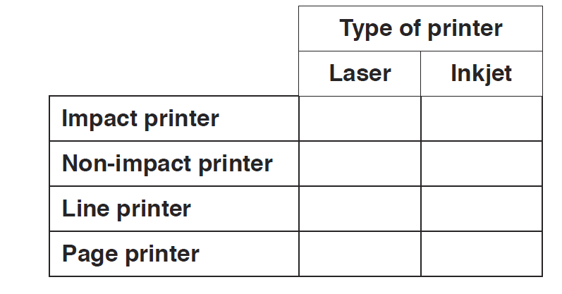

(b) Two of the components of an inkjet printer are a stepper motor and a print head.

Describe how each component is used when printing a page.

(i) Print head

(ii) Stepper motor

5. (a) Name the most suitable input or output device for each of the following uses.

Give a different device in each case.

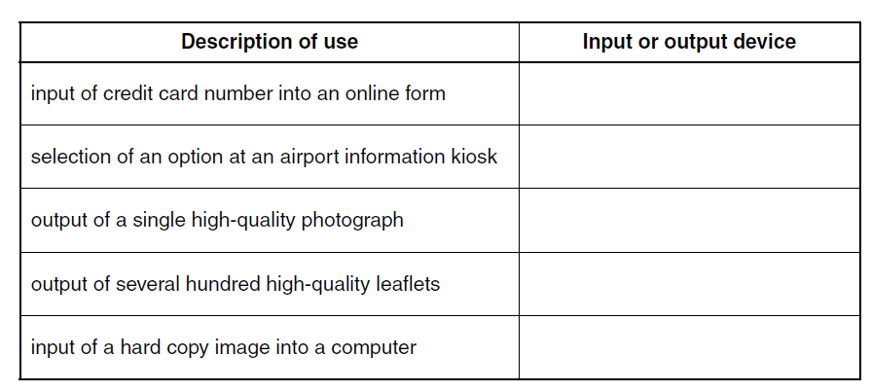

(b)The following table shows a list of five statements which describe the stages when a page is printed using an inkjet printer.

Put each statement in the correct sequence by writing the numbers 1 to 5 in the right-hand column.

